|  |  |  |  |
| --- | --- | --- | --- |
| **TEAM INFO** |  | **Name** | **ID** |
| 1) | Vinayak Singh | 85419240 |
| 2) | Priyansh Mathur | 84491356 |

**Assignment #:** *__* 6*_____________*

**Question #:** *_____*1*_____*

(Question) Input Screenshot below –

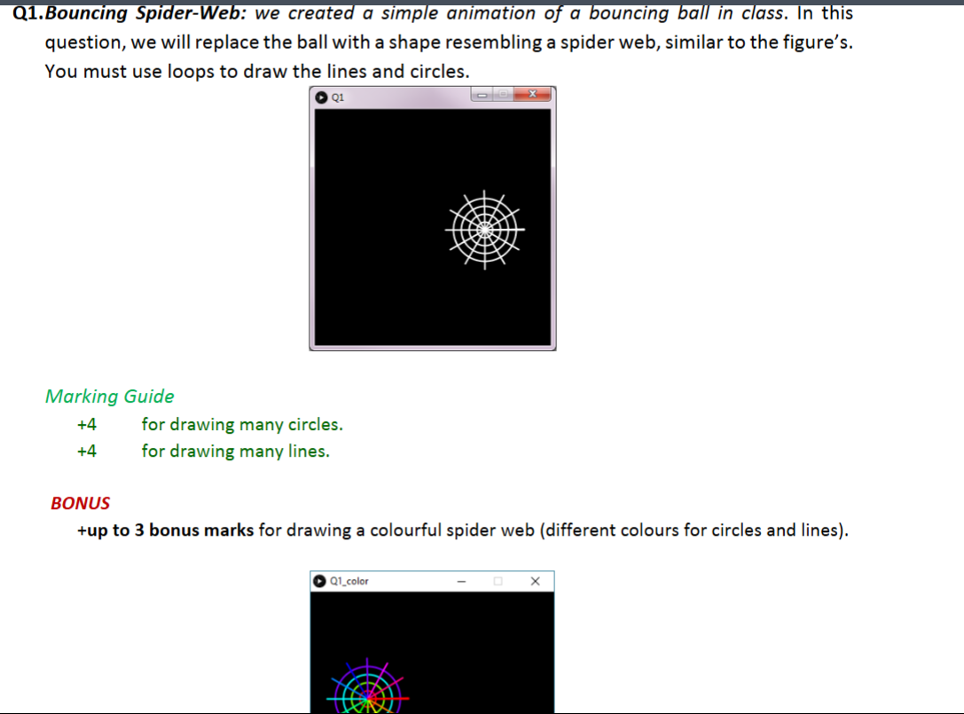

|  |  |
| --- | --- |
| **Code** | **Screenshot of the output** |
| float speedX = 2, speedY = 3;  float x=150, y=150, R = 50;  void setup() {  size(300,300);  stroke(255); strokeWeight(2); noFill();  }  void draw(){  background(0);  colorMode(HSB);  // move spider-web  x += speedX;  y += speedY;  translate(x,y);    // bounce spider-web  if(x > width-R || x < R ) speedX = -speedX;  if(y > height-R || y < R) speedY = -speedY;  // draw spider-web  // REQ1: use loops here to draw many concentric circles.  for(int i =1; i<=5;i++){  stroke(50*i,200,200);  ellipse(0,0,0.3*R*i,0.3*R*i);  }      // REQ2: use loops here to draw many lines. Differnt lines have differnt theta values.  float theta = 0;  float x1,y1;  for(int i=1; i<=12;i++){  x1 = R*cos(theta);  y1 = R*sin(theta);  stroke(30*i,200,200);  line(0,0,x1,y1);  theta+=PI/6;  }  } |  |

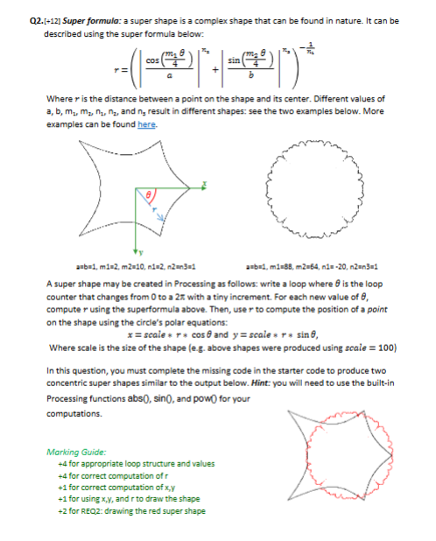

**Question #:** *____2______*

|  |  |
| --- | --- |
| **Code** | **Screenshot of the output** |
| void setup() {  size(400, 400);  strokeWeight(1);  noFill();  }  void draw() {  background(255);  translate(width/2, height/2);  // Black supershape (outer)  stroke(0);  float a1 = 1, b1 = 1;  float m1_1 = 2, m2_1 = 10;  float n1_1 = 2, n2_1 = 1, n3_1 = 1;  supershape(a1, b1, m1_1, m2_1, n1_1, n2_1, n3_1);  // Red supershape (inner)  stroke(255, 0, 0);  float a2 = 1, b2 = 1;  float m1_2 = 88, m2_2 = 64;  float n1_2 = 20, n2_2 = 1, n3_2 = 1;  supershape(a2, b2, m1_2, m2_2, n1_2, n2_2, n3_2);  }  void supershape(float a, float b, float m1, float m2, float n1, float n2, float n3) {  float scale = 100;  beginShape();  for (float theta = 0; theta <= TWO_PI + 0.01; theta += 0.01) {  float part1 = pow(abs((1.0 / a) * cos(m1 * theta / 4)), n2);  float part2 = pow(abs((1.0 / b) * sin(m2 * theta / 4)), n3);  float r = pow(part1 + part2, -1.0 / n1);  float x = scale * r * cos(theta);  float y = scale * r * sin(theta);    vertex(x, y);  }  endShape(CLOSE);  } |  |